**JSliders**

Imports:

* javax.swing.*
* javax.swing.event.ChangeEvent
* javax.swing.event.ChangeListener

Constructor:

JSlider(JSlider.ORIENTATION, int minimum, int maximum, int initial value)

Some additional methods:

* setMajorTickSpacing(int); determines spacing of major ticks
* setMinorTickSpacing(int); determines spacing of minor ticks
* setPaintTicks(true); draws the ticks along the slider
* setPaintLabels(true); labels the ticks along the slider

ChangeListener

{...

demoSlider.addChangeListener(new SliderListener());

…}

private class SliderListener implements ChangeListener

{

public void stateChanged ( ChangeEvent event )

{

JSlider source = (JSlider)event.getSource();

if (!source.getValueIsAdjusting());

{

if (source == demoSlider)

{ (actions to occur when demoSlider is changed) }

}

}

}

Activity

Do not make any changes to VelocityGUI.java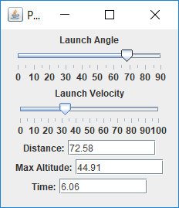

Edit VelocityPanel.java to produce the following otuput: